**Diabetes Prediction Web App using Machine Learning**

**Aim:**

To predict the likelihood of diabetes by analyzing various health-related features such as glucose level, BMI, insulin, and more using classification techniques like logistic regression.

**Programs:**

**Model.py**

import pandas as pd import numpy as np import joblib

from sklearn.model_selection import train_test_split from sklearn.preprocessing import StandardScaler from sklearn.linear_model import LogisticRegression

from sklearn.metrics import accuracy_score, precision_score, recall_score

# Load dataset

df = pd.read_csv("D:/ml_assignment/diabetes_dataset.csv")

# Drop unnecessary columns

columns_to_remove = ["LDL", "Hip Circumference", "WHR", "Diet Type"] existing_columns = [col for col in columns_to_remove if col in df.columns] X = df.drop(columns=["Outcome"] + existing_columns)

y = df["Outcome"]

# Train-test split

X_train, X_test, y_train, y_test = train_test_split(X, y, test_size=0.2, random_state=42)

# Scaling

scaler = StandardScaler()

X_train_scaled = scaler.fit_transform(X_train) X_test_scaled = scaler.transform(X_test)

# Model

model = LogisticRegression() model.fit(X_train_scaled, y_train)

# Metrics

y_pred = model.predict(X_test_scaled) print("Accuracy:", accuracy_score(y_test, y_pred))

print("Precision:", precision_score(y_test, y_pred, zero_division=0)) print("Recall:", recall_score(y_test, y_pred, zero_division=0))

# Save model and scaler joblib.dump(model, "logistic_model.pkl") joblib.dump(scaler, "scaler.pkl")

joblib.dump(X.columns.tolist(), "features.pkl")

**app.py**

import streamlit as st import joblib

import numpy as np

# Load saved components

model = joblib.load("logistic_model.pkl") scaler = joblib.load("scaler.pkl")

features = joblib.load("features.pkl")

# Streamlit config

st.set_page_config(page_title="Diabetes Prediction App", page_icon="◻", layout="centered") st.markdown("""

<style>

.stApp { background-color: #f0f2f6; }

.title {

text-align: center; font-size: 36px; font-weight: bold; color: #4CAF50;

}

.stButton>button {

background-color: #4CAF50; color: white;

font-size: 20px; border-radius: 8px; padding: 10px;

}

</style>

""", unsafe_allow_html=True)

# Title and instructions

st.markdown("<p class='title'>Diabetes Prediction App ◻</p>", unsafe_allow_html=True) st.write("Fill in the details below to predict your diabetes risk.")

# Input form

st.subheader("Enter Your Health Information") input_data = []

col1, col2 = st.columns(2)

for i, col in enumerate(features): with col1 if i % 2 == 0 else col2:

value = st.number_input(col, value=0.0) input_data.append(value)

# Predict button

if st.button("Q Predict"):

input_scaled = scaler.transform([input_data])

prediction = "🛑 Diabetic" if model.predict(input_scaled)[0] == 1 else "✅ Not Diabetic" st.success(f"### Prediction: {prediction}")

**output:**

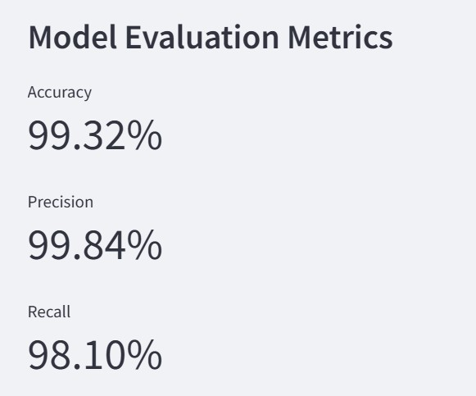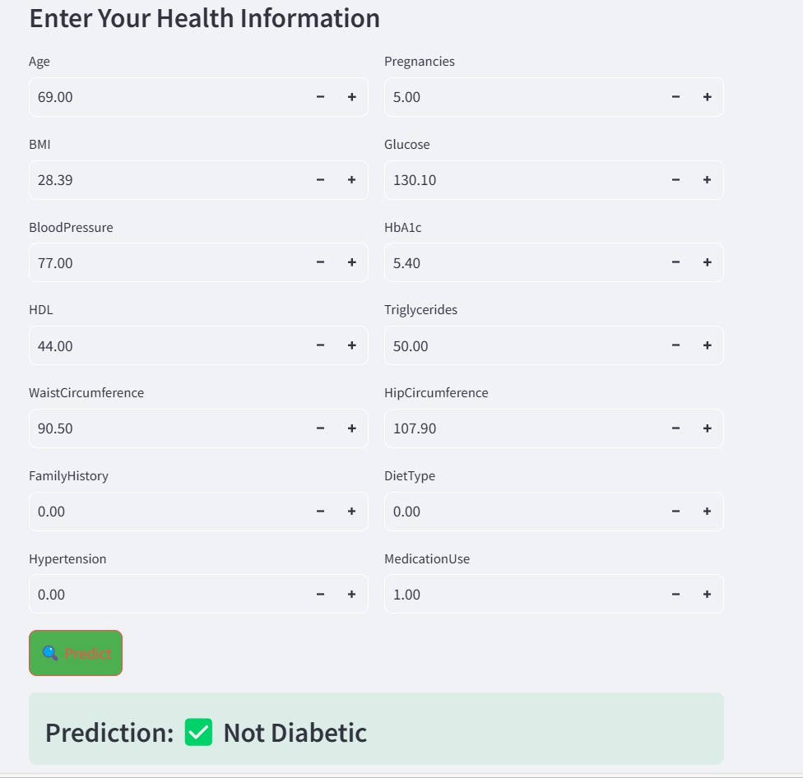

**Link:**



https:/[/www.kaggle.com/datasets/hasibur013/diabetes-dataset](http://www.kaggle.com/datasets/hasibur013/diabetes-dataset)